ASSIGNMENT 4

1Write a select command that produces the order number,amount, and date for all rows in the
orders table?

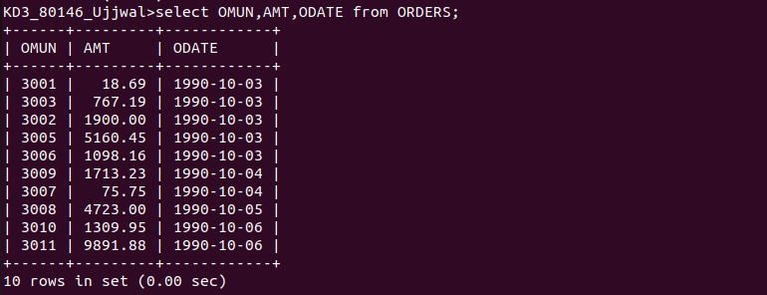

2 write a query that prdouces all rows from the customer table for which the salesperson’s number
is 1001?



3 write a query that display the salespeople table with the column in the following order : city ,sname,snum,comm?



4 write a select command that produces the rating followed by the name of each

customer in San Jose



